10.92: The tension is related to the block’s mass and speed, and the radius of the circle, by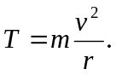 The block’s angular momentum with respect to the hole is 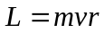, so in terms of the angular momentum,

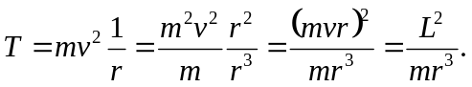

The radius at which the string breaks can be related to the initial angular momentum by
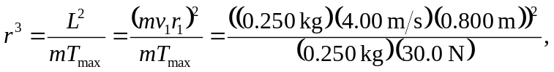
from which 